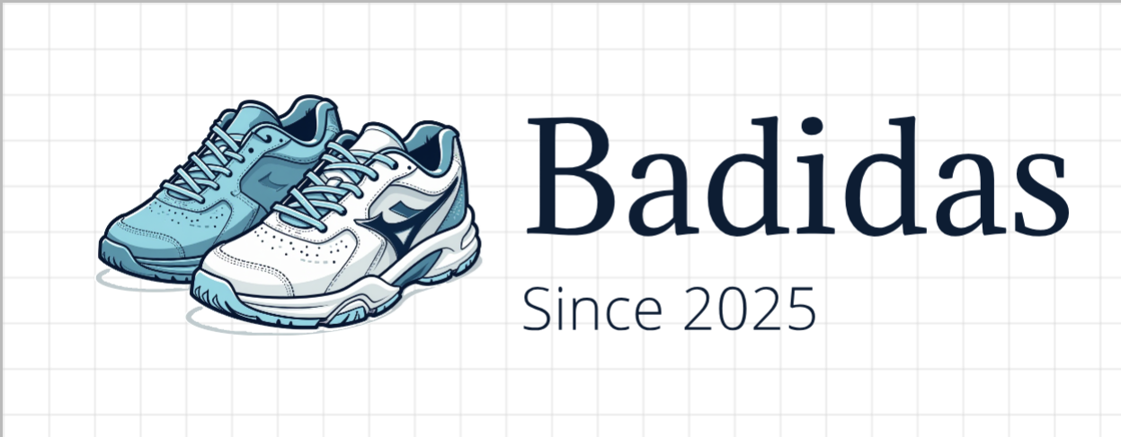

Badidias

Industry #295

Carter Grant, Justin Hoffer, Rafael Labrador

Contents

**Company Strategy** 4

Strategic Vission 4

Branded Footwear Marketing Strategy 4

Overall Branded Strategy 4

Specific Differentiation Choices 4

Private Label Strategy 4

Bid Pricing 4

S/Q 4

Distribution Strategy 4

Production and Distribution Strategy 4

Production Facility Management 4

Branded Footwear Production 5

Distribution Strategy 5

Human Resource Strategy 5

Compensation and Training 5

Corporate Citizenship Strategy 5

Finance Strategy 5

Debt Management 5

Shareholder Equity Management 5

**Performance Review** 6

Y11 Performance 6

Y11 Review 6

Y12 Performance 7

Y12 Review 7

Y13 Performance 8

Y13 Review 8

Y14 Performance 9

Y14 Review 9

Y15 Performance 10

Y15 Review 10

Y16 Performance 11

Y16 Review 11

Y17 Performance 12

Y17 Review 12

**Competitive Analysis** 13

Overall Competitive Landscape 13

**Reflection** 14

Five Learning Outcomes 14

Application to Future Careers 14

# **Initial Company Strategy**

## Strategic Vission

Our strategic vision is to produce high-quality, mid-level affordable shoes that meet the average consumer's needs without sacrificing quality. By offering the widest range of models in the market, Badidas will establish itself as the go-to brand for versatile, accessible footwear while maximizing market share.

## Branded Footwear Marketing Strategy

### Overall Branded Strategy

Badidas aims to implement a differentiation strategy by providing a high number of models to appeal to a broad audience. We will further differentiate ourselves from competitors by manufacturing reasonably priced shoes with high S/Q ratings, making our athletic shoes the superior choice among competitors.

### Specific Differentiation Choices

| **Criteria** | **Compared to Industry Average** |
| --- | --- |
| Retail Price | ABOVE AVG (Due to our focus on having lots of models, we will need to raise the price to match this and provide a high-quality shoe) |
| Search Engine Advertising | AVG (we want to focus on both wholesale and internet, so we will have average advertising for both) |
| Free Shipping | BELOW AVG (we don’t want to do free shipping as this eats away at profits) |
| Internet Market Share | AVG (we want to focus on both wholesale and internet, so we will have average shares for both) |
| Wholesale Price | ABOVE AVG(Due to our focus on having lots of models, we will need to raise the price to match this and provide a high-quality shoe) |
| S/Q Rating | ABOVE AVG(Due to our focus on having lots of models, we want to have a higher quality shoe to sell to customers) |
| Model Availability | ABOVE AVG(this is our main focus, providing lots of model choices to our customers to include everyone) |
| Brand Advertising | AVG(we want to have a good public image, but not spend too much on one type of advertising) |
| Rebate Offer | AVG(we want to be at industry standard here) |
| Delivery Time | AVG(we want to eventually open another factory in Latin America which will help decrease shipping time, but for now, it will be at the average) |
| Retailer Support | ABOVE AVG(We want to have a good public image and one of our main goals is to have lots of models to include everyone, so this is an important one to focus on for us) |
| Retailer Outlets | ABOVE AVG(We want to have a large outreach with our many models, so this is an important one to focus on for us) |
| Celebrity Appeal | ABOVE AVG(celebrity appeal can help us reach customers that normally wouldn’t pay attention to our shoe) |
| Brand Reputation | ABOVE AVG(this is super important to us, as we want to be seen as a brand for all) |

### Why This Bundle of Differentiation Choices Will Lead to High Performance

This bundle will help us stand out due to the large selection and high shoe quality. Not many companies will be selling in this market as having more models raises the price of production, but we believe that we can balance it and take a big share of the market that will differentiate us from the competition.

## Private Label Strategy

We want to use all extra capacity in our factories to fulfill private label orders. We probably won’t have a huge chunk of the private label as we have lots of models, but it is a good thing to have as a fallback if the global wholesale market is lacking

### Bid Pricing

We want to provide the maximum price without losing bids to other companies. We want to make sure that we are still making money from the private label and keep this price at least 15 dollars lower than the average wholesale price

### Private Label S/Q

We want to focus less on S/Q here than in our main production as S/Q isn’t as important for private labels as it is to paying customers.

### Private Label Distribution Strategy

We want to focus on private labels that are in countries with production facilities. This will help us save on cost, exchange rates, tariffs, and shipping so we can offer the private labels a low-cost product while still making money. (start in America as we should have most leftovers here, then move more focus to Latin America as we open a facility there)

## Production and Distribution Strategy

Badidas will prioritize reducing the rejection rate and expanding operations in low-cost labor regions, such as Asia-Pacific and Latin America. Additionally, we will strive to keep distribution costs low by monitoring tariffs/exchange rates and ensuring our production of shoes doesn’t exceed or fall short of each region’s demand.

### Production Facility Management

##### Equipment Purchases

Our company plans to purchase new equipment every two years or as needed in order to successfully expand. We will consider purchasing some refurbished equipment; however, most of our equipment will be new in order to lower the reject rate.

##### Production Improvement Options

We have identified two production improvement options to invest in: options A and B. Option A appears to be a worthwhile investment because it will lower the reject rate, allowing us to produce and sell more of each model. If our project savings are correct, we will earn a return on the investment within four years. Option B is also an attractive opportunity since it saves almost 2k annually, allowing us to earn a return on the investment even quicker. We will most likely prioritize investing in option A for each facility first since lowering the reject rate will be most beneficial for our operations.

##### Construction of New Factories

While our warehouse in North America currently produces most of our shoes, we plan to expand out to Latin America as soon as we can. We will then proceed to build additional space, prioritizing the existing Asia-Pacific and the future Latin America facilities to utilize the low-cost labor.

### Branded Footwear Production

##### Materials Usage

Each year, our super materials will surpass our standard materials usage. Using a higher percentage of superior materials will allow the production of the high quality shoes we aim to create.

##### Enhanced Styling/Features

We plan to spend a baseline amount of $40,000-$50,000 per facility on styling/features to manufacture our shoes. We will increase this amount gradually, aiming to allocate $100,000 toward styling/features by year 17.

##### TQM/6-Sigma Quality Program

Badidas recognizes the need to invest in the TQM/6-Sigma Quality program. Doing so will lower the reject rate, removing waste and maximizing profits. We plan to spend an initial amount of $1.50 per shoe manufactured and will increase the amount as we see fit to maintain a competitive edge in the industry.

##### Capacity Utilization

Our goal is to maximize the capacity of all our facilities in order to produce as many models as possible. However, we will be mindful of our anticipated demand so we don’t overproduce, helping us avoid losing profits. We will reserve using overtime for private label operations, unless we anticipate a high demand for our branded shoes.

### Distribution Strategy

##### Managing Distribution and Warehouse Costs

In order to keep distribution and warehouse costs low, we will be mindful of the fluctuating tariffs and exchange rates and adjust our strategy accordingly. This means identifying the best movement of our products between regions to avoid costly fees. We will prioritize meeting demand for each region by making local shipments first before shipping internationally. However, if we see an opportunity to benefit from an exchange rate, such as a country having a higher valued currency than the producing country, we will ensure to take advantage of it.

##### Inventory Management

Every year, Badidas management will carefully plan for supplying sufficient inventory to meet demand. We will strive to not overproduce, keeping a surplus capped at 150 million for each region. We will do our best to markdown inventory in order to preserve our brand image. However, if we are faced with an abnormally large surplus from previous years, we will mark down a portion of the inventory in order to avoid having total losses.

## Human Resource Strategy

Our human resources strategy is designed to balance competitive compensation, effective training programs, and incentives to maximize workforce productivity and minimize reject rates. By focusing on reject rates and training, we will work to improve the effectiveness of our production while keeping costs at a minimum.

### Compensation and Training

To be competitive in our market, we plan to pay workers approximately the industry average for wages. However, a significant portion of our compensation structure will be focused on incentivizing quality products and low rejection rates. This structure is designed to reward employees for their hard work while also keeping dollars in the company by not having to waste resources.

We will focus on investing in training programs early on in the simulation. This will be a large investment early on, but it will pay off in the long run as our employees will be more skilled and our products will be of higher quality. The training will be focused on quality control, and model-specific production to align with our overall strategy of gaining market share through a wide variety of models.

To ensure continued success, we will monitor all production levels and rejection rates regularly. If we notice a discrepancy in the data, we will work to resolve the issue as quickly as possible and get our production back on track. Overall, we believe this strategy will provide the best success and is aligned with our overall vision as a company.

## Corporate Citizenship Strategy

We believe that responsible actions throughout all aspects of our business will build a positive brand reputation. Rather than making large, one-time investments in corporate citizenship, we will focus more on small, consistent efforts in sustainability, diversity, charity and ethics. We will focus on these small investments each year, and through time we believe these will help boost our brand reputation and build a stronger community.

We are committed to upholding labor practices throughout the world, focusing on sustainability in our actions, and supporting local communities through actions aligned with our brand values. By maintaining this steady approach, we believe we will be able to enhance our reputation year after year as opposed to having to spend large amounts of money each year later in the simulation.

## Finance Strategy

Our finance strategy will focus on leveraging debt responsibility and managing shareholder equity to support growth within the company and maximizing value for our investors. All decisions will be made with a focus on maintaining a strong credit rating while strategically using financial tools to drive expansion and long-term success.

### Debt Management

We will not shy away from debt but rather use it responsibly to fund our growth prospects, such as expanding production into South America and other potential regions. Maintaining a strong credit rating will be at the top of our priorities to ensure favorable borrowing terms. We will be careful to monitor debt-to-equity ratios, interest coverage ratios, and our ability to generate net income to confirm our debt strategy is effective and sustainable.

### Shareholder Equity Management

Our approach to shareholder equity will include the use of stock buybacks and dividend payments to enhance our stock price and improve on return on equity (ROE) metrics. By monitoring other key metrics like earnings per share (EPS), stock price trends, and investor sentiment, we will ensure our actions will positively impact shareholder value and align with our financial goals. Keeping close track of these metrics will strengthen our position in the market and build investor confidence and brand reputation (company image rating).

# **Performance Review**

## Y11 – Y17 Performance Graphs

### EPS

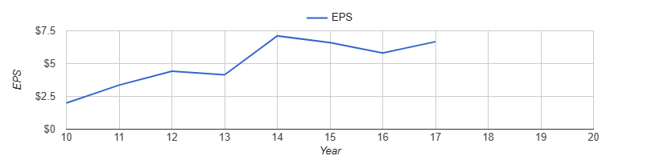

### ROE

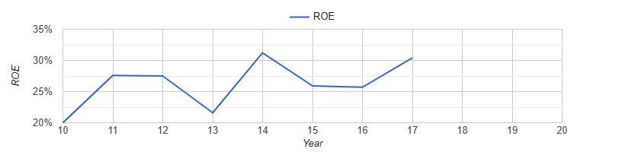

### Stock Price

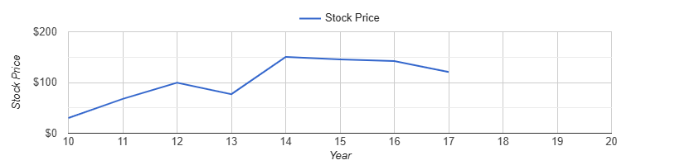

### Credit Rating

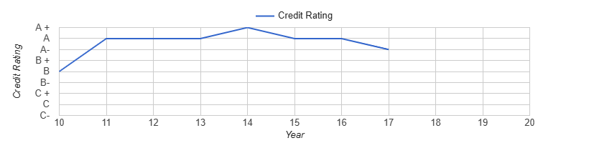

### Image Rating

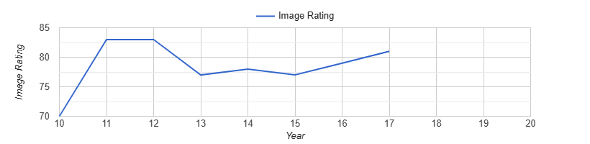

## Y11 Performance

| **Performance Criterion** | **Y10** | **Y11** | **Y11 Investor Expectation** |
| --- | --- | --- | --- |
| EPS | $2.00 | $3.36 | $2.50 |
| ROE | 20% | 27.6% | 21% |
| Stock Price | $40 | $67.73 | $40 |
| Credit Rating | B | A | B+ |
| Image Rating | 70 | 83 | 70 |
| Overall GTD Score | 100 | 110 | NA |

## Y11 Review

### Description of Performance

Badidas had a successful Y11, where we outperformed the industry in most metrics including EPS, ROE, stock price, and credit rating. We attribute this success to our initial differentiation strategy of having a higher model count and slightly below average wholesale price. Specifically, our model availability was 33.35% higher and our wholesale price was 4.4% lower on average across all four regions. While it was surprising to us that we were below average in price, it seemed to work to our benefit. We may alter our strategy to be slightly below average in price if it continues to work well for us. Or, we may strive to be above average if it would result in higher profits.

Most decisions we made seemed to be aligned with our initial indicated strategy. One that may have slightly differed is we decided it would not be worthwhile to make any corporate citizenship investments. Since we achieved an image rating of 83 in the first year alone, exceeding investor expectations by 11 points, we will most likely continue to not prioritize investing in corporate citizenship expenditures. This differs from our initial strategy of making small investments over time to boost our image rating.

### SWOT Analysis

#### Internal Analysis (Strengths and Weaknesses)

**Strengths:**

* One of our biggest strengths was our strong performance in both the Europe-Africa and Asia-Pacific regions. In Europe Africa, we were over 10% above the industry average in every operating performing metric, including over 25% over industry average in Wholesale Operating Profit, Wholesale Operating Profit Margin, and Private-Label Margin Over Cost. In Asia Pacific, we were over 10% over the industry average in Internet and Wholesale Operating Profit Margin, and over 25% above industry average in Private Label Margin Over Cost.
* Another strength in Y11 was our market share across many different regions. For internet marketing, we had over 10% or higher market share in every region, including over 25% higher in Asia-Pacific and Latin America. As for wholesale marketing, we had over 10% or higher market share in the regions of North America, Asia-Pacific, and Latin America.
* A big strength for us this year was our ability to exceed investor expectations. We had the industry best in earnings per share, return on equity, and stock price. Investor expectations were set at $2.50 for EPS, 21.0% for ROE, and $40.00 for stock price, and we were able to get an EPS of $2.50, a ROE of 27.6% and a stock price of $67.73.
  + Our main weaknesses are reject rates, Latin American profit, and delivery time

**Weaknesses:**

* One of our main weaknesses is our reject rates, specifically in North America. With a high model availability, we want to get our reject rates low so we are able to keep a higher percentage of each model we produce. Our reject rate was 10-25% lower than the industry average in North America, which we want to fix for future years.
* Another notable weakness is our delivery time. We are 10-25% lower than average in every region, which is hurting our status with retailers. We will want to adjust this to be more competitive in this market moving forward.
* Another weakness we discovered is our operating performance in Latin America. We are not performing over industry average in any category, and are 10-25% lower than industry average in Internet Operating Profit

#### External Analysis (Opportunities and Threats)

* Our main external threat is company H. They are very similar in price, SQ rating, and market share. They also put a lot of money into advertising so they potentially will attract more customers if we don’t differentiate ourselves
* An opportunity we have to save costs is cutting out the 9$ tariff from shipping to latin America with the creation of our own factory in latin America. We can produce all needs in latin america to save on these costly tariffs.
* Exchange rates are very high between latin america and north america, which is a threat to growing our latin america production in that we don’t want to ship from latin america to north america because the exchange rate is almost 10% difference.

#### Action Items (at least 3 important decisions that you will make next year based on your analysis)

* + One of the biggest decisions we want to make is to increase the price and the SQ rating. We currently have a healthy share of the market in most regions, so increasing the price and SQ will help further differentiate ourselves from our competition as well as increase our profit margin.
  + Another important decision is decreasing delivery time. This was listed as our biggest weakness in the strength and weakness report, and it is a relatively easy fix that isn’t super costly and will lead to big returns in customer satisfaction.
  + We also want to work on making our workers more efficient. Currently, we have one of the lowest productivity rates in north American workers due to our high model count and lower wages. We should focus on putting more money into training the employees especially because we want to increase models and price so this will be crucial in cost saving.

## Y12 Performance

| **Performance Criterion** | **Y11** | **Y12** | **Y12 Investor Expectation** |
| --- | --- | --- | --- |
| EPS | $3.36 | $4.42 | $3.00 |
| ROE | 27.6% | 27.5% | 22% |
| Stock Price | $67.73 | $99.70 | $50 |
| Credit Rating | A | A | B+ |
| Image Rating | 83 | 83 | 72 |
| Overall GTD Score | 110 | 110 | NA |

## Y12 Review

### Description of Performance

Badidas had another strong year in Y12. We maintained the lead in a few of the indicators: EPS, stock price, and credit rating. Although Companies H and A surpassed us on ROE, we are still happy with our performance and plan to increase net profit and repurchase stock in coming years to achieve a higher ROE.

The decisions we made for Y12 were focused on further differentiating ourselves from competitors. We increased several of our competitive efforts, including our model availability by about 50 models across all regions. We invested a significant amount of money into our marketing strategy, specifically for brand advertising, with an average spending increase of 30.4% from Y11. We believe that these strategic investments, along with our strong celebrity appeal, competitively priced shoes, and high production volume (13,776 total pairs) drove strong demand for our shoes and secured an above-average market share.

### SWOT Analysis

#### Internal Analysis (Strengths and Weaknesses)

**Strengths:**

1. **1.Strong Private Label Margin and Market Share:** The company has performed well in private label margins, indicating a strong competitive position in private-label products. Market share in both wholesale and internet sectors is also a strength.
2. **Wholesale and Internet Market Share in Europe and Asia:** The company outperforms competitors in these regions, suggesting a strong brand presence and successful marketing strategies.
3. **Improved Latin America Profits:** The company has managed to enhance profitability in Latin America, signaling progress in this region, we will want to continue investing money for advertising and attract more market share.

**Weaknesses:**

1. **Production Labor Costs Across All Regions:** High production labor costs are affecting profitability and could become a concern for long-term cost control (especially in North America so it might be useful to outsource)
2. **Decreased North American Profits and Margins:** Despite strong performance in other regions, North America has seen not as strong profits and margins, indicating a need for corrective action in that market.

#### External Analysis (Opportunities and Threats)

**Opportunities:**

* There is cost-saving potential by working to eliminate/reduce tariffs on shipments to Europe from America through shipping through Asia or Latin America.
* Local Latin American production can fulfill regional demand, reducing reliance on expensive imports and the saved labor costs of this factory will lead to long-term cheaper costs of labor.

**Threats:**

* Company I remains a strong competitor due to similar pricing, SQ rating, and models. We hold the bigger market share though.
* Company A’s high advertising expenditure and low costs could keep drawing customers away unless we differentiate our brand and increase advertising.
* High exchange rate differences (almost 10%) between Latin America and North America make exporting from Latin America to North America less viable for now.

#### Action Items (at least 3 important decisions that you will make next year based on your analysis)

* Rather than putting money into the North American plant, our team will move a portion of the production away from it into the Asia Pacific and Latin America facilities due to the expensive labor costs.
* With the recent consumer report emphasizing how consumers are more interested in Internet shopping and immersive experiences in stores, we decided to increase our marketing efforts across the board. In internet marketing, we increased our spending in every region, most notably an increase from $4,750 to $7,250 in Latin America.
* As competition is expected to stiffen up, and tariffs are increasing the cost of goods sold, we are focusing on implementing some financial strategies to keep return on equity high this year. We will be issuing a $1.00 dividend and buying back 400 shares of stock with some of our excess cash this year.

## Y13 Performance

| **Performance Criterion** | **Y12** | **Y13** | **Y13 Investor Expectation** |
| --- | --- | --- | --- |
| EPS | $4.42 | $4.15 | $3.50 |
| ROE | 27.5% | 21.6% | 23% |
| Stock Price | $99.70 | $76.95 | $65 |
| Credit Rating | A | A | B+ |
| Image Rating | 83 | 77 | 72 |
| Overall GTD Score | 110 | 104 | NA |

## Y13 Review

### Description of Performance

Year 13 was a step back from the previous company successes in Y11 and Y12. We still managed to heavily outperform investor expectations, but we regressed in every metric across the board. We are no longer the best in the industry in EPS, ROE, or Stock Price, however we have maintained a top 3 position in EPS and Stock Price and we sit in 4th place for ROE. Although there was some regression, we are still happy with our performance and look forward to making some adjustments that will benefit us in future years.

This year, in an effort to reduce costs we decided to lower our S/Q rating a few points. This decision to lower our quality seemed to have an adverse result on our market share (see *Image 1*) and sales, which will be something to keep in mind moving forward. We also decided to increase our attention to private label operations, specifically where we had competitive price advantages in Europe-Africa and Latin America. This allowed us to bring in more revenue for our extra capacity that was not utilized as much in previous years.

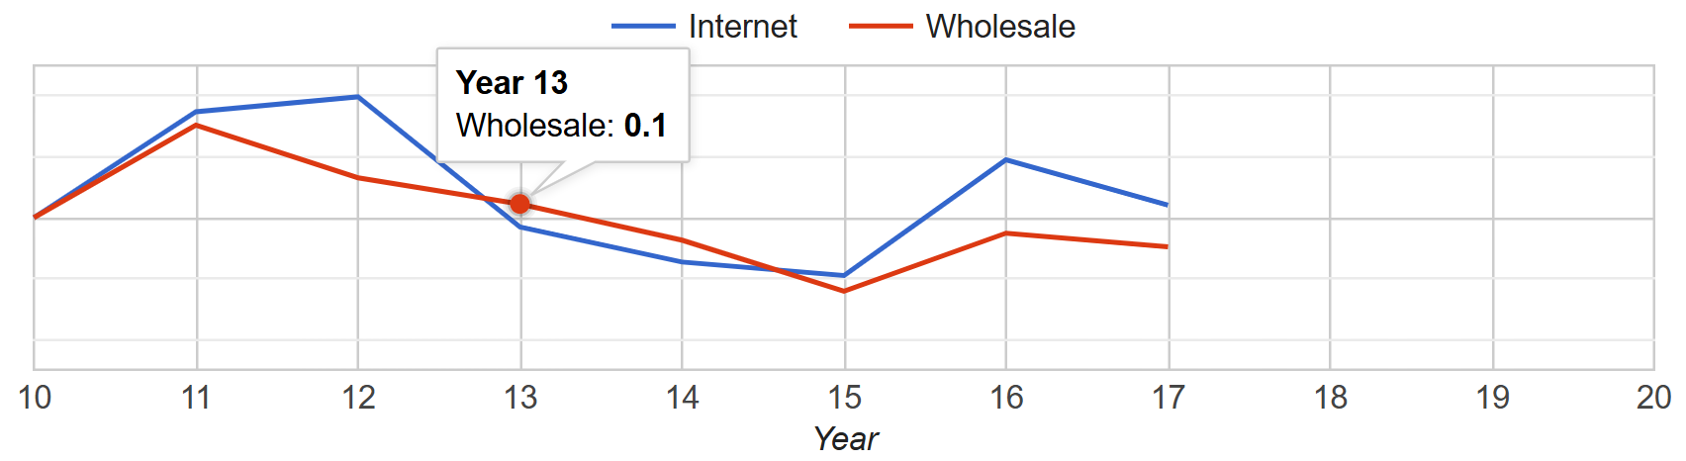

*Image 1: Market share declines in the North America region for Year 13.*

### SWOT Analysis

#### Internal Analysis (Strengths and Weaknesses)

**Strengths:**

1. **Strong Performance in Latin America:** The company was boosted this year by a strong performance in the Latin American region. Our internet market share was over 5 points above the industry average, and our market share in the wholesale segment was over 2.6 points above the industry average, as well as a strong 22.2% market share in the private-label segment. We also managed to have higher-than-industry-average profit margins in all three segments, resulting in very strong performance throughout the region.
2. **Improved Production Costs in North America and Asia-Pacific:** Production costs in all regions were one of our weaknesses in Y12, so we made it an emphasis to cut costs this year. In North America, we were able to reduce costs by $1.68 per pair, in Asia-Pacific, we were able to reduce the production cost per pair by $2.70 per pair, and in Latin America, we were able to bring costs per pair produced down by a whopping $5.89 (see *Image 2*).

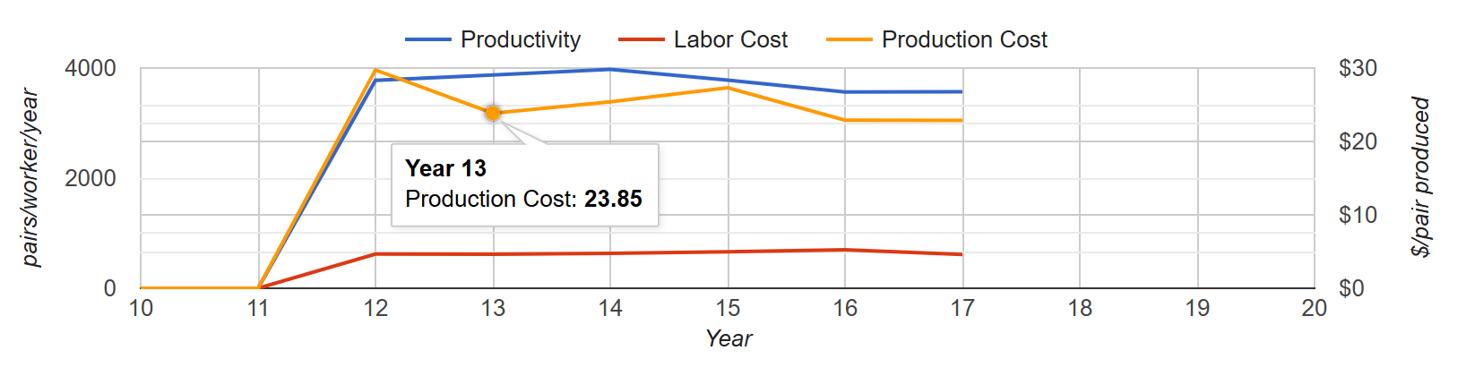*Image 2: Production cost decreases at the Latin America plant in Year 13.*

1. **High Operating Profit Margins:** In Europe-Africa, Asia-Pacific, and Latin America, we were able to facilitate operating margins in both the wholesale and the internet segments that were above the industry average. In fact, in Asia-Pacific, we were 0.1% away from having the highest wholesale operating profit margin at 19.9%.

**Weaknesses:**

1. **Low TQM/6-Sigma Spending:** With our high-model strategy, we initially aimed to lead in TQM spending to maintain a low reject rate. However, this year we fell below the industry average across all regions. In Asia-Pacific, we spent just $1.90 per pair—$1.27 below the average. In Latin America, our $2.30 spend was 45 cents lower, and in North America, our $1.50 spend was 90 cents below the industry average.
2. **Highest-in-Industry Production Costs in North America:**  At our North American facility, our $30.38 spent per pair produced marks the highest in the industry, which was about 11% more than the industry average of $27.45. This is in part due to our decision to use 70% superior materials in the production of our shoes, which is also the highest percentage in the industry, as we work to raise our S/Q rating.
3. **Pairs Demanded Below Industry Average in North America:** This year, we were 6.9% below the industry average with 2,238 pairs demanded in North America. With our strategy of high models paired with a high S/Q rating, our demand being below the industry average is concerning. We want to be sure to gain a large market share in all categories across the board, and will work to get this up in future years.

#### External Analysis (Opportunities and Threats)

Opportunities:

1. **Decrease in New Industrial Equipment Prices**: Recent 10% drop in equipment prices offers a cost-effective opportunity to upgrade or expand production capacity. We have been planning on expanding our production in both Latin America and Asia-Pacific and this decrease in cost of new equipment will allow us to continue to increase our S/Q rating at a lower cost.
2. **Favorable Exchange Rates Shipping Into Europe-Africa**: After exchange rates negatively impacted our performance in Europe-Africa this year, next year’s outlook is more favorable. Rates for shipments from Asia-Pacific are projected to improve by 10.3%, and by 8.6% from Latin America, making it more cost-effective to serve the region from our lower-cost facilities.

Threats:

1. **Stockouts Gained in Latin America:** Our strong performance in Latin America was partially boosted by gaining 256,000 additional pairs sold due to competitor stockouts. While beneficial in the short term, this poses a potential threat, as we cannot rely on competitor supply issues to drive sales. If rivals improve their inventory management, we risk losing this added volume.
2. **Exchange Rates Eating into Profits:** Last year, our largest and only exchange rate deficit occurred in Europe-Africa, impacting us by just $0.24 per pair on internet sales and $0.17 on wholesale sales. This year, we faced exchange rate deficits in every region except North America, across both wholesale and internet segments. In Europe-Africa wholesale alone, our -$2.54 per pair sold resulted in a total cost of $6,443,000 to the company. This is something we need to be more mindful of next year to carefully decide where to send each pair of shoes produced.

#### Action Items

1. **Increase TQM Spending in All Regions**: Our strategy centers on offering high-model footwear with a strong emphasis on S/Q rating, yet this year we saw a decline in S/Q from 6.7 to 6.3 across all regions. This drop indicates that our current TQM investment is not supporting our quality objectives. Increasing TQM spending will help reduce reject rates, improve overall efficiency, and better align with our high-model strategy aimed at boosting S/Q ratings and achieving long-term cost savings.
2. **Relocate Production Away from North America:** With our North American production costs the highest in the industry, and costs over $6.00 lower per pair in Latin America and more than $7.00 lower in Asia-Pacific, we’ve decided to sell off all production equipment in North America. We’ll expand capacity by adding space for 2,000 additional pairs in Asia-Pacific and 1,000 in Latin America, which is supported by a recent 10% drop in industrial equipment prices.
3. **Focus on Increased Marketing In Europe-Africa**: With our shift to producing solely in Asia-Pacific and Latin America, we now have lower costs that can improve margins in the Europe-Africa region. Combined with recent exchange rate changes, this creates an opportunity to grow market share through increased marketing efforts.

## Y14 Performance

| **Performance Criterion** | **Y13** | **Y14** | **Y14 Investor Expectation** |
| --- | --- | --- | --- |
| EPS | $4.15 | $7.11 | $4.00 |
| ROE | 21.6% | 31.2% | 24% |
| Stock Price | $76.95 | $150.21 | $80 |
| Credit Rating | A | A+ | A- |
| Image Rating | 77 | 78 | 75 |
| Overall GTD Score | 104 | 105 | NA |

## Y14 Review

### Description of Performance

After a challenging Y13, we delivered a strong performance in Y14, surpassing all investor expectations. Our EPS rose to $7.11, well above the $4.00 target, and our stock price nearly doubled from $76.95 to $150.21. ROE increased from 21.6% to 31.2%, exceeding the 24% goal. Strong celebrity endorsements boosted our consumer appeal scores—first in Asia-Pacific and second in all other regions—which helped drive a 20.3% increase in net sales revenue. Improved TQM spending also reduced reject rates and supported higher profit margins, contributing to a one-point gain in our Overall GTD Score.

We didn’t make any major strategic shifts in Y14 but stayed focused on delivering high-model, high-quality shoes. While competitors like Company I and D have moved into similar territory, we maintained our edge with a wide offering of 450 models and strong S/Q ratings. Our credit rating improved to A+, and our image rating rose to 78. A particularly strong showing in Europe-Africa helped lift our overall performance, though rising tariffs and tightening competition will be key challenges to watch in the year ahead.

### SWOT Analysis

#### Internal Analysis (Strengths and Weaknesses)

**Strengths:**

1. **High Celebrity Appeal Across All Regions**: With a celebrity consumer appeal score that tied for first in Asia-Pacific at 225, alongside strong second-place scores of 205 in North America, 215 in Europe-Africa, and 210 in Latin America, we saw a boost in sales and demand. As a result, our Net Sales Revenue increased from $725,713 in Year 13 to $873,102 in Year 14, a 20.3% increase.
2. **Strong Market Share in Every Region but North America:** Excluding North America, we achieved an above-industry-average market share in every region across both wholesale and internet segments. Our strongest performance was in Europe-Africa wholesale, where we captured a 14.9% market share, which was 3.8 percentage points above the industry average. We even managed to capture some private-label market share, with 13.5% in LA and 18.1% in E-A.
3. **Reduced Reject Rates due to Increase in TQM Spending**: We were able to take one of our biggest weaknesses from Year 13, low TQM spending, and implement a successful change that led to improved reject rates. In Year 12, we were among the industry’s lowest in TQM spending. This year, we were the industry’s highest in both Asia-Pacific and Latin America at $4.00 per pair produced. As a result, reject rates in Asia-Pacific dropped from 6.8% to 5.3%, and in Latin America from 5.7% to 4.5%.

**Weaknesses:**

1. **Poor Performance in North America:** In North America, our marketing and advertising efforts were below the industry average across the board. Most notably, our brand advertising spend of $14,000 was 34.9% below the industry average. As a result, only 2,027 retailers were willing to carry our brand, 10.3% below the average. Our market share in both the internet and wholesale segments also lagged, averaging 2.2 percentage points below the industry average.
2. **Below Average Profit Margins in Latin America:** Last year, our operating profit margins were one of our key strengths, particularly in Latin America. While we did manage to increase margins in both the internet and wholesale segments this year, our internet operating profit margin of 22.3% was 4.2% below the industry average, and our wholesale margin of 24.4% was only slightly above the average by 1.3%. Other companies were able to maximize their margins by much more than we were.
3. **Highest-In-Industry Regular Compensation**: Although we have not increased our regular compensation in recent years, we still had the highest regular compensation per worker in both our Asia-Pacific and Latin American facilities. It appears that every other company is cutting labor costs, which is helping improve their profit margins, unlike us.

#### External Analysis (Opportunities and Threats)

**Opportunities:**

1. **Decreased Tariffs Shipping To North America**: North America has reduced tariffs to $2 per pair for all imports, creating a cost advantage. Although we no longer produce in North America, this allows us to increase shipments from our Asia-Pacific and Latin American facilities. With higher tariff rates now in place between other regions, this presents a timely opportunity to boost margins and strengthen our position in the North American market.
2. **Competitor Stockouts**: While it’s not a sustainable strategy to rely on competitor stockouts, we benefited this year from Company I experiencing stockouts in every region except Latin America and company A experiencing a large stock out in LA. As a result, we gained approximately 134,000 additional sales—49,000 in Europe-Africa, 25,000 in Asia-Pacific, and 60,000 in Latin America. While not all of these can be directly attributed to Company I, it’s a trend worth monitoring in future years.

**Threats:**

1. **Increase in Tariffs in All Regions but NA:** New tariffs of up to $15 per pair between Asia-Pacific, Latin America, and Europe-Africa will significantly raise shipping costs. With all our production based in Asia-Pacific and Latin America, we are heavily exposed. Meanwhile, our market share in North America remains low, and despite $2 tariffs in that region, we’re limited in our ability to shift focus there to reduce cost impact.
2. **Competitors Inching Into our Market Share**: After our early successes, several competitors have begun adopting similar strategies and have gradually chipped away at our market share. While we continue to outperform many of them, companies like Company I and Company D are worth watching. Both have shifted to a high-model strategy, with slightly lower S/Q ratings and prices than ours. Each holds over 10% market share in nearly every region and segment, posing a growing threat as we work to expand our global presence.

#### Action Items

1. **Increase Marketing Efforts in North America**: Our SWOT analysis identified North America as a weakness, with below-average market share and low retailer support. With newly lowered tariffs in the region, we now have a cost advantage that creates a strong opportunity for growth. To capitalize on this, we need to significantly increase marketing and advertising efforts to boost brand visibility, capture more market share, and drive sales. We will max out brand advertising all the way up to 30,000, as well as increase internet advertising in our efforts to have a stronger year next year.
2. **Differentiate Ourselves From Competition:** With competition tightening year after year and global sales expected to cool, it’s becoming increasingly important to stand out. To stay ahead, we will increase our number of models from 450 to 500, offering greater variety to attract a wider range of consumers. We also plan to raise our S/Q rating by at least 0.3 points in all regions, reinforcing our position as a premium, high-quality brand and helping us stand apart in a crowded market. These changes will hopefully allow us to differentiate ourselves from competitors who have entered close to our market, specifically Companies I and D, who have lower S/Q ratings than us.
3. **Raising Prices Across All Regions**: After experiencing stagnant profit margin growth last year, it’s essential that we take steps to improve profitability. With new tariffs increasing our production and shipping costs, we plan to raise prices by approximately $2–$5 across all categories. This adjustment will allow us to pass some of the added costs on to customers, rather than absorbing them fully as a company, helping to protect and grow our margins in the face of rising external pressures.

## Y15 Performance

| **Performance Criterion** | **Y14** | **Y15** | **Y15 Investor Expectation** |
| --- | --- | --- | --- |
| EPS | $7.11 | $6.60 | $4.50 |
| ROE | 31.2% | 25.9% | 25% |
| Stock Price | $150.21 | $145.65 | $100 |
| Credit Rating | A+ | A | A- |
| Image Rating | 78 | 77 | 75 |
| Overall GTD Score | 105 | 102 | NA |

## Y15 Review

### Description of Performance

In Year 15, Badidas met all investor expectations but experienced a noticeable decline across key performance indicators, resulting in a drop to 6th place on the GTD scoreboard. While we maintained strong wholesale market shares in Europe-Africa (14.8%), Asia-Pacific (13.7%), and Latin America (13.6%), our decision to cut brand advertising entirely in North America—where the industry average was $21,056—significantly reduced our market share in that region to just 7.6%. This weakened our overall position, especially as competitors captured a stronger presence in the North American market. Additionally, we had below-average operating profit margins in most regions, with Europe-Africa being the lowest at 11.2%, due largely to intense tariffs of up to $15 per pair. Our bids in the private-label segment were also all unsuccessful, further impacting total revenue.

Strategically, we expanded our model count to 450 in an attempt to stimulate demand and target a broader consumer base. However, this decision brought us too close to competitors offering similarly priced shoes with overlapping S/Q ratings, weakening our ability to differentiate effectively (see *Image 5*). Combined with our minimal marketing efforts in North America and rising competition in our intended segment, these factors contributed to our lower BII score (75) despite competitive performances in other areas.

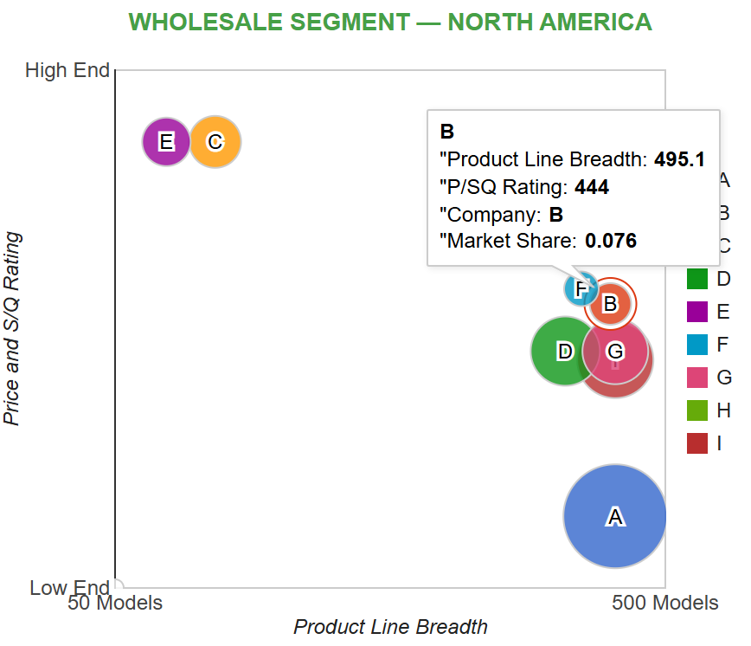

*Image 5: North America wholesale segment shows a cluster of companies Badidas is now intensely competing against.*

### SWOT Analysis

#### Internal Analysis (Strengths and Weaknesses)

**Strengths:**

1. **Strong internet segment presence**: Our policy of offering free shipping in key regions helped secure internet market shares that were, on average, 2% above the industry average. This is significant as the market trend continues to shift toward online purchases, positioning Badidas to capitalize on changing consumer preferences more effectively than competitors.
2. **Industry-leading TQM/6-Sigma investments**: With $4 per pair produced spent on TQM/6-Sigma (compared to $2.94 in AP and $2.73 in LA), we achieved a lower reject rate and an S/Q rating that was, on average, 1.75% higher than the industry average. This strength is critical because higher quality can justify increased pricing—an essential factor in improving our weak profit margins.
3. **Robust marketing in EA, AP, and LA**: Our brand advertising was 23% higher and our search engine advertising was 31.8% higher than the industry average, averaged across the EA, AP, and LA regions. These marketing efforts supported our above-average market shares in these regions.

**Weaknesses:**

1. **Low celebrity appeal**: Our celebrity appeal scores were well below regional averages (e.g., 85 in NA vs. 106 average), undermining our brand equity and customer loyalty. This weakness is critical because celebrity endorsement can help influence consumer buying decisions.
2. **Subpar operating profit margins**: Despite competitive market shares, our operating margins in EA, AP, and LA were 5.6% below industry averages, averaged across the three regions (see example in *Image 6*). This limits our profitability and long-term growth potential, especially in tariff-heavy regions where margins are already strained.

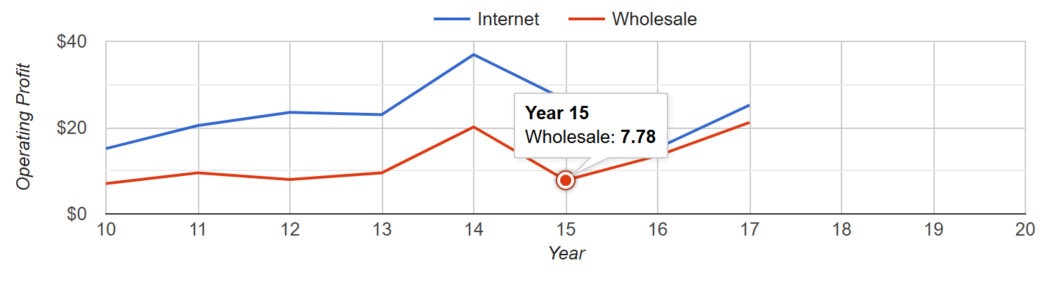

*Image 6: Europe-Africa wholesale operating profits see a decline in Y15, down to $7.78.*

1. **North America underperformance**: NA lagged in every metric, from brand awareness to market share, due to our underinvestment in marketing. This was our lowest-performing region, and its weakness had a ripple effect on our global rankings. Rebuilding this region is essential for regaining competitive balance.

#### External Analysis (Opportunities and Threats)

**Opportunities**

1. **Rising online purchasing trends** – As more consumers prefer to shop online, expanding our free shipping and search engine ad strategies can attract a larger customer base with relatively low marginal cost. This complements our current strengths and allows for scalable growth.
2. **Renewed importance of retailer support** – The shift toward "mom and pop" specialty stores in Y16 presents a chance to gain favor among independent retailers by enhancing our retailer support. This would improve shelf presence and brand accessibility in the wholesale segment.
3. **Underserved premium segment** – With competitors crowding the mid-range market, we have a strategic opportunity to lead in the high-end category through model variety and superior S/Q. Doing so would help us regain differentiation and restore our competitive edge.

**Threats**

1. **Segment overcrowding** – With four major competitors (D, G, I, F) active in our target market segment, price wars and S/Q parity are eroding the effectiveness of our differentiation strategy. This intensifies competition and makes market share gains more difficult.
2. **Tariff barriers** – High tariffs from LA and AP to EA (up to $15/pair) drastically reduce our cost competitiveness and hurt margins. If unaddressed, this could continue to depress regional profitability, regardless of demand or quality.
3. **Global oversupply** – With maximum output exceeding demand by 27.6% in the industry overview report, the market is heavily saturated. This oversupply leads to price compression, reducing profitability across the board and making cost efficiency more important than ever.

#### Action Items (at least 3 important decisions that you will make next year based on your analysis)

1. **Improve operating profit margins** to exceed 20% by increasing prices in EA and raising S/Q ratings, especially to offset the impact of tariffs and clearly separate ourselves from price-sensitive competitors.
2. **Rebuild North America** as a stronghold by raising brand and search engine advertising to above-industry levels, enhancing retailer support, and reestablishing consumer trust and recognition.
3. **Expand internet segment advantages** by offering free shipping in at least one additional region and boosting online ad presence to match shifting consumer behaviors.

## Y16 Performance

| **Performance Criterion** | **Y15** | **Y16** | **Y16 Investor Expectation** |
| --- | --- | --- | --- |
| EPS | $6.60 | $5.81 | $5.25 |
| ROE | 25.9% | 25.7% | 26% |
| Stock Price | $145.65 | $142.36 | $125 |
| Credit Rating | A | A | A- |
| Image Rating | 77 | 79 | 77 |
| Overall GTD Score | 102 | 101 | NA |

## Y16 Review

### Description of Performance

While some of our key performance metrics like EPS, ROE, stock price, and our GTD score were slightly down compared to last year, Year 16 was still a fairly successful year for Badidas. We didn’t hit the ROE target investors set, but we actually had the highest ROE in the industry—showing that overall, it was a tough year for everyone. Slower global demand likely contributed to weaker numbers across the board, which makes our improved BII score (84) and movement up to 3rd place on the GTD scoreboard even more meaningful.

One of our biggest wins came from improving our operating profit margins. For example, in Europe-Africa, margins increased from 11.2% to 19.4% in the wholesale segment. While overall profits declined slightly, our drop (11%) was much smaller than some competitors—Company A, for instance, saw a 33% decline. This tells us that our efforts to increase profit margins paid off. We also shifted our strategy this year by raising prices and reducing our model count, aiming to move away from crowded competition and reestablish our differentiation. Our prices were about 4–5% above regional industry averages. That likely hurt demand a bit, as our market shares came in below average. On the plus side, our private-label bids were much more competitive this year, and we landed contracts in 3 of 4 regions.

### SWOT Analysis

#### Internal Analysis (Strengths and Weaknesses)

**Strengths:**

1. **Strong celebrity appeal**: We signed contracts with three celebrities, and our appeal scores shot up across the board—well above industry averages leading into next year (e.g., 235 vs. 106 in North America—see *Image 7*). This boost is important because celebrity endorsements directly influence buyer decisions and help solidify our premium brand image.

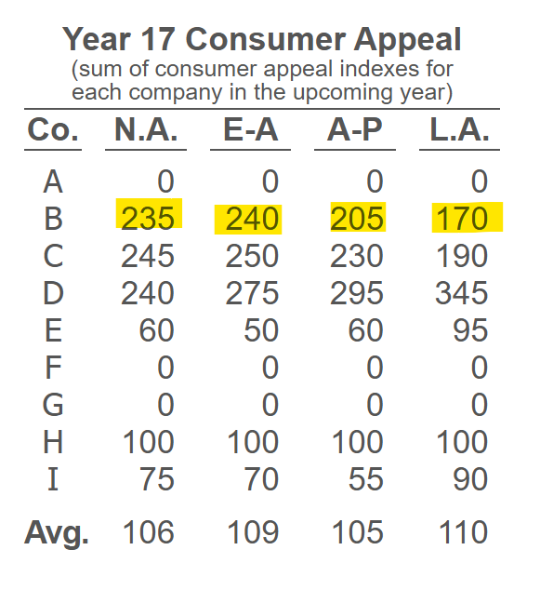

*Image 7: Badidas has strong celebrity consumer appeal leading into Y17.*

1. **Faster delivery times**: We reduced delivery times from two weeks to just one across all regions. Along with stronger retailer support in NA, AP, and LA, this helped improve customer experience and supported our market share during a competitive year.
2. **Higher profit margins in EA**: Our wholesale profit margin in Europe-Africa was 5.7% above the industry average, which shows that our pricing strategy and efficiency improvements are starting to work in at least some regions.

**Weaknesses:**

1. **Image rating still low**: Despite some gains, our image rating sits at 77, which is on the lower end compared to other companies. This matters because image rating affects how consumers and retailers perceive us. A couple of weak years in private-label bids and little investment in CSR probably haven’t helped here.
2. **Below-average wholesale market share**: Our wholesale market share came in 1.6% below the industry average across regions. This likely ties back to our higher prices. While our shoes are high quality, demand seems to dip when prices are too far above what consumers are used to (see *Image 8*).

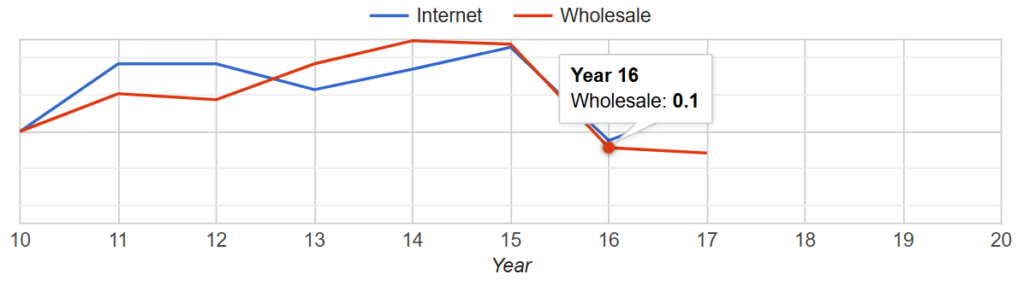  
*Image 8: Europe-Africa experienced a decrease in market share in Y16, likely due to raising our prices.*

1. **Internet and wholesale profit margins still lagging**: Especially in EA and LA (internet) and AP (wholesale), we’re not seeing strong margins. One factor could be our higher-than-average marketing spend—for example, we spent $42.76 per pair in AP, about $7.58 more than the average. That kind of overspend eats into profits quickly.

#### External Analysis (Opportunities and Threats)

**Opportunities:**

1. **Free trade across EA, AP, and LA**: With no tariffs between these regions, it makes sense to focus more production and shipping here. It’s a good chance to lower costs and improve profitability without changing much else.
2. **Favorable exchange rate from AP to EA**: Shipping shoes made in Asia-Pacific to Europe-Africa will save us around 2% in costs due to exchange rates. It’s a relatively small percentage, but it's the best exchange rate opportunity to take advantage of.
3. **Room for more competitive pricing**: If we can slightly reduce prices while keeping our quality high, there’s an opening in the market to attract more value-focused customers. This could help us grow our market share next year.

**Threats:**

1. **High tariffs on North America imports**: Shipping into North America still comes with a $12 per-pair tariff. That makes it much harder to compete profitably in that region and forces us to be extra cautious with how we manage operations there.
2. **Heavy market saturation**: Looking ahead, total global supply at full capacity is now 35.4% higher than projected demand (see *Image 9*). That means everyone’s going to be fighting for a limited number of customers, putting a lot of pressure on pricing and profit margins.

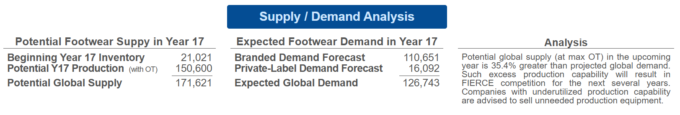

*Image 9: The Industry Overview report shows how much global supply (at max OT) will exceed projected demand.*

1. **High-volume competitors**: Companies D and A are producing more shoes than anyone else. Their shoes may not be the highest quality, but their lower prices could win over cost-sensitive buyers—especially in a saturated market.

#### Action Items (at least 3 important decisions that you will make next year based on your analysis)

1. **Focus on winning private-label bids**: We’ll continue submitting strong bids in hopes of boosting market share and improving our image rating. Private label wins can help stabilize production volume and improve our overall brand strength.
2. **Slightly lower prices to boost demand**: We’re aiming for a better balance between quality and affordability. By adjusting our prices to be more competitive, we can bring more buyers in without losing our premium positioning.
3. **Send more AP-made shoes to EA**: To cut costs, we’ll prioritize shipping shoes from Asia-Pacific to Europe-Africa, where the exchange rate will save us about 2% in production and delivery expenses.

## 

## Y17 Performance

| **Performance Criterion** | **Y16** | **Y17** | **Y17 Investor Expectation** |
| --- | --- | --- | --- |
| EPS | $5.81 | $6.67 | $5.25 |
| ROE | 25.7% | 30.4% | 26% |
| Stock Price | $142.36 | $120.73 | $125 |
| Credit Rating | A | A- | A- |
| Image Rating | 79 | 81 | 77 |
| Overall GTD Score | 101 | 91 | NA |

## Y17 Review

### Description of Performance

Year 17 turned out to be a tough final year for Badidas. Even though we beat most of our investor expectations—earning an investor score of 97—our overall GTD score dropped to 91 due to a lower BII score of 67. Looking back, one of the biggest factors that impacted our performance was a missed opportunity in the Europe-Africa region. In Year 16, we intentionally cut marketing costs in that region to maintain profitability despite heavy tariffs—and that decision seemed to have paid off at the time. But heading into Year 17, we failed to ramp marketing expenses back up to remain competitive. In the end, we spent 48.4% less on brand advertising than the industry average in Europe-Africa, which likely contributed to our low wholesale market share of just 8.8% in that region. If we could go back, we’d definitely increase our marketing efforts in Europe-Africa to boost demand and strengthen our presence there, likely resulting in a higher score for Y17.

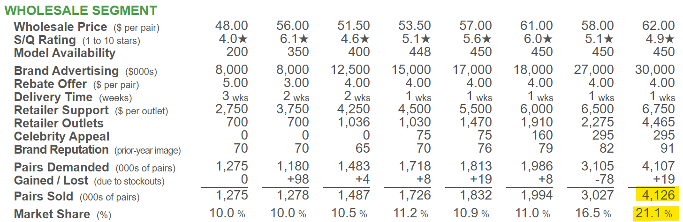

*Image 10: Company D’s competitive efforts in the Asia-Pacific region, Y10 – Y17. It’s clear that company D rapidly expanded in years Y16 and Y17, which was largely unexpected.*

Another major challenge came from outside our control: Company D’s massive expansion. Their internet and wholesale sales jumped from 16.9 million to 20.4 million pairs in just one year (see example of Asia-Pacific region in *Image 10*). This kind of growth was unexpected and gave them a dominant position across the board. If we had seen that coming, there are a few strategic moves we would have considered:

* Lowering some of our prices to stay competitive since volume played a bigger role than we realized.
* Putting more resources into retailer support and delivery speed to help us stand out in ways beyond pricing.
* Scaling up production earlier to better compete in a high-volume environment.

Overall, even though the final numbers weren’t what we hoped for, we still see Year 17 as a learning experience. **\*\*Note to Dan or grader**:** We are hopeful that the effort we put into the simulation and the strong performance in previous years (>100 GTD score from Y11-Y16) will be considered in the final BSG grade.

#### Internal Analysis (Strengths and Weaknesses)

**Strengths:**

1. **High Celebrity Appeal** – Our company maintained well above-average celebrity appeal across all regions, which helped attract customers and reduce the need for heavy marketing spend. By securing multiple celebrity endorsements at a relatively low cost, we were able to strengthen our brand influence without overextending our budget.
2. **Strong Private-Label Performance** – We outperformed competitors in the private-label segment in all regions except Latin America. With available factory capacity, we were able to fully commit to private-label production and successfully secured contracts in all four regions—helping us boost volume and factory utilization.
3. **Above-Average S/Q Rating and Model Availability** – We maintained both an above-average style/quality (S/Q) rating and a strong variety of model offerings. While many competitors focused on lower-cost, lower-priced strategies, we carved out space in the mid-to-upper tier market by offering higher quality shoes with broader selection.

**Weaknesses:**

1. **Low Marketing Spend in Europe-Africa** – Our brand advertising in Europe-Africa was significantly below the industry average, which directly contributed to our underperformance in market share.
2. **Wholesale Operating Profit Struggles** – While our internet margins held steady, the wholesale segment took a hit across most regions. A highly competitive environment, paired with prices that were likely set too high, made it difficult to maintain healthy profit margins.
3. **Market Share Decline** – We lost market share in three of the four regions this year (see example in *Image 11*), with Asia-Pacific being the only region where we held above-average numbers. Our aggressive pricing strategy didn’t play out as expected, and we underestimated how much it would impact customer demand.

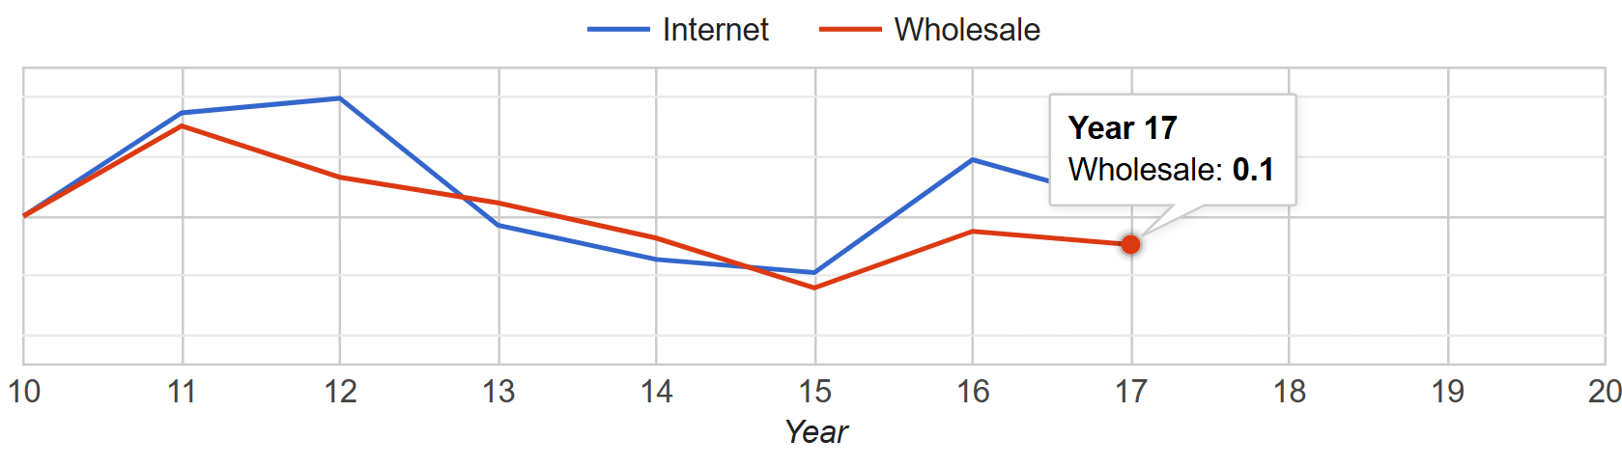

*Image 11: Market share in the North America region showed a decrease from Y16 to Y17.*

#### External Analysis (Opportunities and Threats)

**Opportunities:**

1. **Reopening North American Factory Capacity** – Reinvesting in our North American production facilities could help reduce the impact of tariffs and allow us to serve the region more cost-effectively in the future.
2. **Leverage Celebrity Appeal with Competitive Pricing** – Now that our celebrity appeal is strong, lowering our prices slightly could help us win back market share quickly. With the right balance of affordability and brand power, we’re well positioned to attract more customers next year.

**Threats:**

1. **Dominance of Companies A and D** – These competitors continue to spend heavily on advertising and keep their costs low, which makes them difficult to compete with on both visibility and pricing. Without further brand differentiation or operational efficiency, it’ll be tough to keep up.
2. **Persistent North American Tariffs** – High tariffs continue to make North America a challenging region to operate in, especially for imported goods. This could limit our growth and profitability there until we adjust our production and shipping strategy.

#### Action Items (at least 3 important decisions that you will make next year based on your analysis)

1. **Adjust Pricing and Quality to Capture Value Market** – To take advantage of our available factory space and strong celebrity appeal, we plan to slightly reduce both the price and quality of our models to better compete in the lower-cost market segment.
2. **Revitalize the Wholesale Segment** – Given the recent decline in our wholesale market performance, especially in North America, we’ll be shifting our focus toward strengthening this segment. This includes reallocating resources from internet marketing to increase investment in wholesale advertising and retailer support. Our goal is to rebuild market presence in regions where we’ve fallen behind and restore balance across both segments.
3. **Enhance Shareholder Returns through Financial Strategy** – As industry competition tightens and tariffs continue to raise production costs, we’ll be using some of our excess cash to support shareholder value. Specifically, we plan to issue higher dividends and repurchase 400 shares of stock to help improve our return on equity and maintain investor confidence.

# **Competitive Analysis**

## Overall Competitive Landscape

Our BSG industry saw intense competition, especially in the Internet and Wholesale segments. Badidas positioned itself strongly across multiple performance metrics, especially in pricing strategy and market share. However, some competitors outpaced Company B in profit, cost per pair made, and marketing/market share, revealing important strategic gaps. Badidias started the game off strong with us being in first place for the first 2 years, but as competition started to copy us, we fell behind by rising prices too much and losing our once large market share. Overall, our industry was very competitive with all the companies having very similar scores.

### Analysis of Competitor 1

Company A dominated the market by consistently using a low-price, high-volume strategy. With the lowest Internet Price at $68.50 and Wholesale Price at $49, it secured the largest market share across both segments.

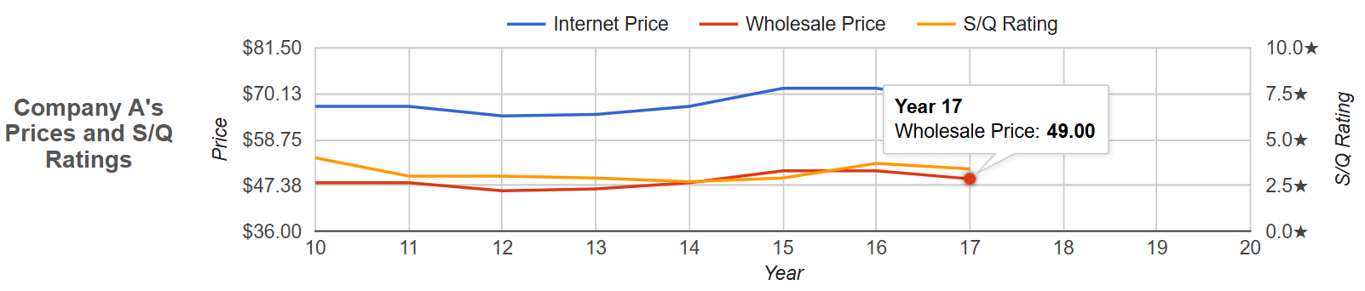

*Image 12: Company A’s prices and S/Q ratings in the North America region, Y10 – Y17.*

Their success came not from flashy branding or high celebrity appeal, but from sheer affordability and broad accessibility. This forced competitors to either follow suit with price cuts or find other ways to differentiate. Group A was leading for multiple years and only started falling recently due to the competition starting to copy them and due to lower profit margins.

### Analysis of Competitor 2

Company D took a hybrid approach throughout especially in year 17, balancing moderate pricing with broad retail availability. They had prices including Internet Price: $87 (mid-range), Wholesale Price: $62 (cheaper), Wholesale Demand: 4,383,000 pairs (second highest). This was on the lower end of the price, they also had lower S/Q rating than competitors, which allowed them to save on production costs.

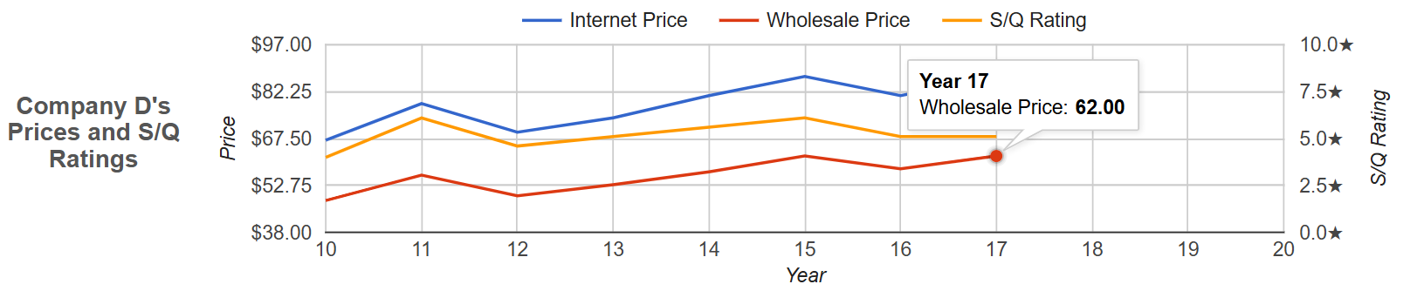

*Image 13: Company D’s prices and S/Q ratings in the North America region, Y10 – Y17.*

Despite not having the lowest prices, Company D outperformed many competitors thanks to many factors such as strong delivery times and retailer support, strong production efficiency, and high model counts. This strategy proved effective in securing high unit sales without entering a full price war with group A who dominated in having the cheapest shoes.

# **Reflection**

Badidas started the simulation with a strong competitive edge. For the first two years, we held 1st place by offering competitive prices and maintaining a balanced marketing and quality strategy. Our early success proved that appealing to value-conscious consumers and winning volume could yield fast growth.

However, in later years, we shifted our focus toward increasing profit margins by raising prices. While this may have improved short-term per-unit profitability, it hurt our volume and market share, especially in the face of Company A’s aggressive low-cost strategy and Company D/I’s similar approach to us. As competitors captured larger portions of the market through affordability and broader reach, our sales and rankings dropped. This experience showed us the delicate balance between profit and volume, and the risks of shifting strategy without fully accounting for competitor behavior or consumer price sensitivity.

## Five Learning Outcomes

1. **Cost Leadership Drives Volume**: Low prices can be a dominant strategy when executed efficiently, especially in markets where brand differentiation is limited and competition is stiff.
2. **Raising Prices Has Trade-offs**: Maximizing margins isn’t always optimal, especially if it causes a drop in demand and long-term market position.
3. **Market Share Momentum Matters**: Once lost, it’s hard to regain share without heavy reinvestment in price cuts or advertising. We noticed it was a lot harder to get back that which we used to have.
4. **Competitor Monitoring Is Crucial**: Company A’s continued success was no surprise—they stayed consistent with their pricing. We should’ve adjusted earlier to account for them.
5. **Success Requires Strategy Cohesion**: Pricing, quality, marketing, and operations must align. Disconnected strategies create confusion and inefficiency.

## Application to Future Careers

This simulation mirrored many real-world dynamics of competitive strategy, from pricing decisions to brand positioning, and taught us the importance of adaptability. In future roles whether in marketing, analytics, operations, or executive leadership, this experience has practical applications. These include:

* Understanding how pricing affects demand elasticity
* Balancing short-term profit goals with long-term market share
* Analyzing competitor behavior before making major strategic shifts
* Learning to respond quickly to negative trends with data-driven actions

Ultimately, this exercise has made us more prepared to navigate business environments where every decision counts, and where agility and foresight can be the difference between growth and decline.

# **AI Disclaimer**

Portions of this report were drafted with the assistance of ChatGPT. AI was used to help improve the clarity, tone, and structure of the content based on performance data and strategic insights provided by the team. All final decisions, strategic interpretations, and edits were made by the Badidas team.